A picture containing object

Description generated with high confidence

**Your Organization’s Logo Here**

**CONFIDENTIAL DOCUMENT**

**DO NOT POST THIS DOCUMENT ON**

**WALLS OR BULLENTIN BOARDS**

**Emergency Procedures Plan**

**_______ State Office Building**

**108 Banana Street**

**Emergency Procedures Plan**

**___________ Building**

The safety of all employees and other persons in the building is the highest priority. The Emergency Procedures Guideis intended familiarize employees and provide direction in responding to multiple types of emergency situations.

**Table of Contents**

Assignment of Responsibilities…………………………………………...……………Page 3

Emergency Contact List………………………………………………………...………Page 4

Evacuation………………………………………………………………………………Page ?

Fire, Toxic Fumes, Gas…………………………………………………………………Page ?

Workplace………………………………………………………………………………Page ?

Power Outage……………………………………………………………………………Page ?

Medical Emergency……………………………………………………………………..Page ?

Suspicious Package………………………………………………………………………Page ?

Bomb Threat…………………………………………………………………………… Page ?

Panic Buttons……………………………………………………………………………Page ?

Lock Down Buttons……………………………………………………………………..Page ?

Code Adam Alert………………………………………………………………………..Page ?

Departments, Divisions/Offices Emergency Contact List……………………………....Page ?

Emergency Telephone Tree……………………………………………………………..Page ?

**ASSIGNMENT OF**

**RESPONSIBILITIES**

**Name 1 Here, Emergency Coordinating Manager (ECM), Name 2 here, Deputy Emergency Coordinating Manger,** will assume the responsibility of the evacuation, coordinating messages and instructions to other departments, the Agency of ________ Central Office, fire and police departments.

**All names here, Building Liaisons** are responsible for the weekly radio tests to Safety Wardens to ensure all radio transmissions are working and responsive. During the time of evacuation, the Building Liaisons account for and communicate with Safety Wardens and Emergency Coordinating Manager while assisting during an evacuation.

**Safety Wardens** are responsible for having an up-to-date roster of employees working in their division/office during normal business hours. This roster will account for employees while at the designated evacuation location. A magnetic or dry-erase version on the wall may be used with the Safety Warden taking a photo of it as they evacuate.

**Floor Safety Wardens/Floor Leaders (if used in larger buildings)** are responsible ensuring for all common areas on their floor including the hallway, conference rooms, restrooms, and storage areas have been evacuated. They will communicate to the ECM a head count and location of people still inside the building.

**Employees** are responsible for knowing what to do in case of an emergency, and to follow instructions issued by the ECM. Employees will help visitors and clients of their division or meeting during an evacuation. **Employees are responsible for their own safety at all times.**

Emergency Contact List

|  |  |  |
| --- | --- | --- |
| **Contact** | **Cell Number** | **E-Mail** |
|  |  |  |
|  |  |  |
|  |  |  |
|  |  |  |
|  |  |  |

**The __________ Fire Department has access to the building using the “Knox Box”.**

**24/7 Statewide Security Phone Number: (802) 828-0777**

**Staff should use the numbers listed below if a facility or safety issue occurs at the _________ Building during non-business hours**

|  |  |  |
| --- | --- | --- |
| **BGS** | **Cell Number** | **E-Mail** |

**EVACUATION**

The __________ State Office Building has a single evacuation plan for all emergencies; fire, medical, and police related.

When ordered to evacuate the building, all employees are expected to use the nearest safe exit. Safety Wardens will ensure employees do not use the elevators. A floor plan showing escape routes is to be posted in each suite area and any waiting areas for clients/customers. Employees should know where the **designated area of refuge** is on each floor (if used) and should assist visitors, paying close attention to persons with disabilities and/or difficulty vacating the premises.

Safety Wardens of each suite will hang **EVACUATED** signs on suite doors prior to exiting the building. They will assist anyone unable to use the stairs to the area of refuge. Floor Safety Wardens will verify evacuation signs are present on each suite door and will check that all shared areas on their floor including the hallway, conference rooms, restrooms, and storage areas are evacuated. If evacuated sign is missing from a suite door, the Floor Safety Warden will verify no one is in the suite. The Floor Safety Warden will stay with those in the area of refuge and communicate with the Building Liaison that people are still in the building and location.

**Designated Areas of Refuge Locations**: **Floor and room number with description, if used.**

**Fire Alarm (Alarmed) Evacuation**

All employees will initially assemble at locations __________________________________

1. The Safety Warden from each division/office will use the staff roster to report to the ECM (or Floor Leaders as appropriate) that all staff, visitors, and clients have been evacuated.
2. In the event of a major emergency, the Emergency Coordinating Manager will coordinate with other designated emergency managers to assemble at ___________________ to share information and assess the situation.
3. This type of evacuation should be no longer than one hour. Once employees sign in with their division/office Safety Warden they should remain in contact with their Safety Warden for updated messages of return to building. If evacuation is during inclement weather, the Emergency Coordinating Manager, or Building Liaison, will message Safety Wardens via mobile radio with instructions of indoor evacuation location and instructions. The locations listed below provide the requirements of indoor safety and security for employees.

***TBD***

1. The Emergency Coordinating Manager will notify own higher HQ, Office of Security (phone number is on back of State ID Cards), and BGS Regional Manager that an emergency exists and status.
2. Full descriptions of Safety Warden Procedures and map locations are attached to this document. *(add map locations, etc., to this document)*

**Non-Fire Alarm Evacuation by Law Enforcement, Fire Department, or other Official Public Safety Entity.**

This type of evacuation may encompass an area lock down, chemical spill, or evacuation of another building (i.e. Federal Building, Court House) and may continue over the course of a few to several hours. Employees may be unable to access their vehicles from the _________State Office Building garage (_______ Street) during that time.

Employees will be notified via VT Alert with a message about the situation.

1. All employees will initially assemble at locations identified on the **middle of** xxxxxxx Street unless otherwise instructed for a secondary evacuation location.
2. In the event of a major emergency, the Emergency Coordinating Manager will coordinate with managers at the corner of xxxxxxx Streets to share information and assess the situation.
3. The Incident Commander leading the emergency event will keep the Emergency Coordinating Manager updated so that managers and employees are apprised of the situation. Frequent messages with update of the event will be sent via mobile radios to Safety Wardens and/or by VT Alert and disseminated to employees.

The location(s) listed below provide the indoor safety and security for employees needed to accommodate upwards of _______ employees.

***TBD***

FIRE

Any person in the bulding is authorized to activate a fire alarm. The building should be evacuated promptly.

The Safety Wardens should be the last to leave after checking the office areas, restrooms and waiting areas to be sure everyone has been evacuated. Once outside, the Safety Wardens provide an accountability report to the Emergency Coordinating Manager (ECM) and then return to their group and maintain control of them. If needed, Safety Wardens can appoint employees to aid in traffic control; keeping arriving private vehicles from entering the area and employees from leaving. Safety Wardens shall also ensure no one re-enters the structure without endangering themselves or entering the collapse zone of the building (distance away from the building determined by the height of the walls).

TOXIC FUMES, GASES, AND VAPORS

1. If a suspicious odor is smelled by anyone, especially if it has a rotten egg smell, evacuate and call 911.
2. If a Carbon Monoxide (CO) alarm sounds, pull the fire alarm and evacuate.
3. Employees will evacuate the immediate area, and aid visitors and other customers in doing the same.
4. Notify the Emergency Coordinating Manager (ECM) that you have called the fire department.

#### WORKPLACE SAFETY FROM VIOLENCE

_____________________________________________________________________________________________

1. If a staff member, visitor, or client is **assaulted** or is in **imminent danger**, call 911.

Facilities with a “Panic Button” linked to Home Security Monitoring Company should use that devise only if calling 911 is unavailable or impractical due to the circumstances.

1. AFTER calling 911, any urgent events should be reported to the 24-hour BGS security phone at (802) 828-0777 (found on the back of newer employee ID cards). The BGS Security line is answered by a Security Officer who can make the proper security notifications to other personnel.
2. When an incident occurs that involves a Vermont State employee, Vermont State property, or a visitor to a Vermont State facility, the incident should be documented with the BGS Office of Security. Employes are to alert their Emergency Coordinating Manager and their own supervisor.
3. This can be done by accessing the BGS website at <http://www.bgs.vermont.gov> and selecting “Report a Security-Related Incident”.
4. When an employee submits a BGS incident form, it goes to key members of the Office of Security who then will respond, potentially by e-mail or telephone.

Bottom of Form

1. Other examples of assistance from Security and reasons to fill out this form include having a security detail assigned to the building site of the incident or threat, adding/replacing alarms on doors or windows, adding/replacing locks on doors or

windows, temporarily re-assigning staff to a safer work location, modifying the site in some other manner, receiving assistance with no-trespass orders or other safety measures. Contact your Emergency Coordinating Manager.

1. If assistance is being requested, the Emergency Coordinating Manager (ECM) should contact the BGS Office of Security by telephone after an incident report has been submitted. Phone number is on the back of the State ID Card.

Hostile Intruder

“ALICE” is the State’s options-based approach to response to a hostile intruder in the workplace. These steps, *which are not in any particular order*, afford the State employee who has received training on ALICE, options for their own survival should they be in proximity to a hostile intruder.

**ALICE is an acronym for: Alert, Lockdown, Inform, Counter, Evacuate**

**A = ALERT** is when you first become aware of a threat. When you are alerted to the danger how to tell others.

**L = LOCKDOWN** If evacuation is not safe, barricade the entry point. This more than locking a door. Use furniture in the room to barricade the entrance to the room. Use other materials such as a belt or electrical cord to wrap around door knob or door closer to keep a person from opening the door

**I = INFORM** Throughout the event, someone who can continuously report real-time information about the incident if possible. Inform police to the whereabouts of the individual(s) and identity. Try to inform employees / visitors of the whereabouts so they can decide whether to barricade or flee

**C = COUNTER** As a last resort when life is in danger, use countering strategies to impact the intruder’s effectiveness. Whether you are alone or working together as a group. Attempt to incapacitate the shooter. Spread out. Act with physical aggression. Commit to your actions. Throwing objects at the intruder to distract. Physically overwhelm the intruder

**E = EVACUATE** Employees have permission to evacuate – they may access ‘off limit’ areas, or break a window to escape. If there is an escape path, a choice is to evacuate.

**A person must use their own discretion during a hostile intruder event as to whether they decide to act.**

POWE R OUTAGE

1. In case of a power outage, employees shall alert their managers who will contact the Building’s Emergency Coordinating Manager (ECM).
2. The ECM will keep all departments within the building up-dated on the status and anticipated length of the outage.
3. Depending upon the length of the outage, the ECM will contact those listed on the Emergency Contact List for Building Issues (see page ***update page #***).
4. During weekend hours, any staff that becomes aware of a power outage will use the Emergency Contact List for the Maintenance Department to inform them of a power outage.
5. During the outage, employees shall turn off their computers and any other surge-prone devices like TVs and even microwaves. If the power turns on and off a few times before remaining on, or there is a power surge during the initial re-enstatement of power, having these electronics disconnected from the power source will prevent them from being damaged. Wait until power is on (and not flickering) for over 5 minutes before turning them back on.
6. If the power is out over 8 hours, inspect and remove food/liquids that can spoil in office refrigerators. A refrigerator that is ½ full will maintain food at a safe temperator for 24 hours if left closed.
7. Depending on your organizations mission, consider the purchase and staging of flashlights, batteries, and phone chargers in the work area. Work areas that do not have natural light should have wall-mounted rechargeable flashlights that are easily accessable to employees. Consider mandating that employees download a NOAA Radio App to their govt. cellphones to maintain connectivity to weather alerts during power outages.
8. Do not use generators within the work environment to provide electricity due to the risk of carbon monoxide poisoning.
9. Provide more steps here for your building, like tasking people with particular duties.
10. If your building has a generator, list here how long it can last on one tank of gas and how it gets refueled.

MEDICAL EMERGENCY

**If a medical emergency occurs, call 911 immediately!**

All departments/floors should have a first aid kit on site. First aid kits are intended to assist with initial treatment of minor injuries. First aid kits at a minimum should include: small, medium and large sterile gauze dressings, gloves, cold packs, first aid tape, roll of gauze, bandages, first aid guide, antiseptic wipes, and face mask (for CPR use). First aid kit contents vary and additional contents can be purchased separately. Following any injury, staff should consider calling 911 for emergency medical services.

If 911 has been activated, the Safety Warden will identify the entrance to bring the medical first responders (ambulance crew) in and designate employees to greet the emergency vehicles and escort them to the patient. Wherever there is a closed door or an elevator, an employee will be staged to ensure the door is unlocked and held open for the first responders to facilitate their rapid and most direct arrival to the patient.

**Immediate Intervention and Assistance**

Licensed or certified medical professionals such as Public Health Nurses or Emergency Medical Technicians may provide immediate intervention and assistance as necessary and to the degree in which they are competent to provide, until the Emergency Medical Service arrives. All observations and information gathered should be shared with EMS when they arrive.

**Documentation**

If an injury occurred within a State Office Building a BGS Incident Report at

<http://www.bgs.vermont.gov> and selecting “Report a Security-Related Incident”.

SUSPICIOUS PACKAGES

Employees should visually inspect their mail before they start to open it. Items to consider that would make a letter or package suspicious are below.

If a letter or package seems suspicious to anyone handling it, at that time, it should be set down and the room or area is to be evacuated. Then an employee should call 911. Anyone that handled the item should wash their hands in soap and water once in a safe location.

While the chances of encountering suspicious mail are low, employees who identify any suspicious item should remember the Three P’s:

* **P**ackage: Isolate the area where the mail piece was found—do not touch it.
* **P**eople: Clear the area of people. Notify your supervisor.
* 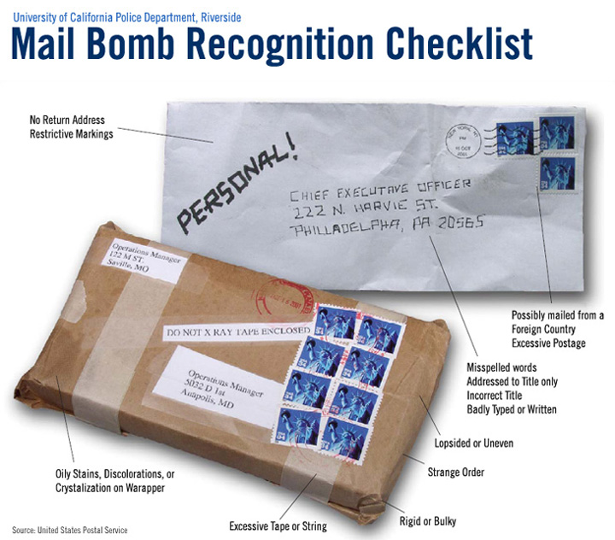**P**lan: Follow your building’s Emergency Procedures Plan (this document).

BOMB THREAT

Should you receive a call alerting you to a bomb threat try to gather information if there is time.

During the call, the person receiving the call should:

1. Stay calm and don’t argue or get angry with the caller.
2. Attempt to find out why the caller is upset: reason for the threat.
3. Identify the type of threat and who the threat is directed at.
4. Note and remember as many details as possible.
5. Consider placing caller on speaker phone so other employees can hear and take notes.
6. Get as much information as possible about the threat and motives. (See “Bomb Threat Checklist” on next page.)
7. **Don’t hang up.**

After the call:

1. Do not hang up the phone. Even after the caller hangs up. It may aid in tracing the call.
2. Employees shall call 911 and then alert their supervisor or Emergency Coordinating Manager (ECM).
3. Write down the exact threat; the entire statement if possible, as soon as possible.
4. Evacuate only if directed by Police or the ECM. Follow the guidelines per the Evacuation Section of this document.

Note: Elevators can be used for evacuation.

**BOMB THREAT CHECKLIST**

**CALLERS VOICE**

**CALLERS VOICE**:

**______ Calm ______ Nasal**

**______ Angry ______ Stutter**

**______ Excited ______ Lisp**

**______ Slow ______ Raspy**

**______ Rapid ______ Deep**

**______ Soft ______ Clearing throat**

**______ Laughter ______ Deep breathing**

**______ Crying ______ Cracking voice**

**______ Normal ______ Disguised**

**______ Distinct ______ Accent**

**______ Slurred ______ Familiar**

**______ Squeaky ______ Whispered**

**If voice is familiar, who did it sound like?**

______________________________________________

BACKGROUND SOUNDS:

BACKGROUND SOUNDS

**______ Street ______ Factory machines**

**______ Crockery ______ Animals**

**______ Voices ______ Clear**

**______ PA System ______ Static**

**______ Music ______ Local**

**______ House ______ Long distance**

**______ Motor ______ Booth**

**______ Office ______ Other**

**THREAT LANGUAGE**

THREAT LAN GUAGE:

**______ Well Spoken (Educated) _______ Irrational threat maker**

**______ Incoherent _______ Tape**

**______ Foul _______ Message read by**

**Remarks __________________________________________________________________**

REPORT CALL IMMEDIATELY TO 911

Panic Buttons

Panic buttons are devices used to summon law enforcement in an emergency where you are not able to dial 911. **Panic buttons are not meant to replace calling 911**. The preferred method of summoning law enforcement is by telephone so you are giving critical information to a dispatcher.

If, during an emergency, the VoIP phones and/or WiFi are inoperable, use a fax line to call 911.

**Panic buttons should not be used for medical emergencies. For a medical emergency 911 is the communication method.**

Panic button procedures when law enforcement arrives

(*include procedures*)

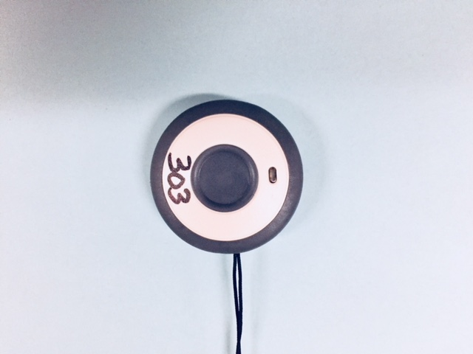

**PUSH BUTTON**

**FOR 3 SECONDS**

If activated accidentally, contact the Home Security Monitoring Company and provide account number and passcode immediately following activation.

**Panic Button Notification Numbers**

|  |  |  |  |
| --- | --- | --- | --- |
| **Name** | **Account Number** | **Office** | **Passcode** |
| Home Security Monitoring Company |  | 1-800-933-4762 |  |
| 1st Floor Account Number | 205-xxxx |  | Xxxx1 |
| 2nd Floor Account Number | 205-xxxx |  | Xxxx2 |
| 3rd Floor Account Number | 205-xxxx |  | Xxxx3 |

Lockdown Buttons

Lockdown buttons are used where the public access staff at a visitor window. They are used to limit access in an incident such as a bomb threat, hostile intruder or other emergency where the movement throughout the building should be limited. Any employee can activate a lockdown button in the event of an emergency.

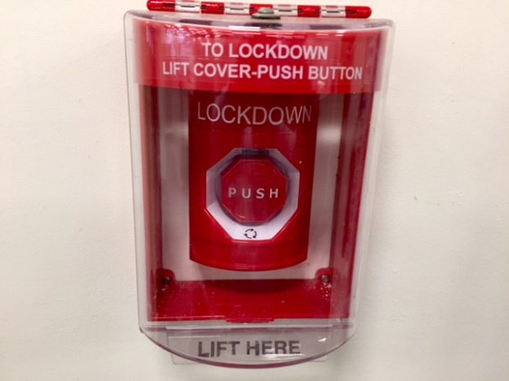

**PUSH BUTTON**

LIFT TO OPEN COVER

Once a lockdown button is activated the employee should notify the Emergency Coordinating Manager immediately. The Emergency Coordinating Manager will make notifications to the required agencies such as law enforcement/office of security.

After an incident is over, the Emergency Coordinating Manager will be required to contact the office of security to reset the lockdown button.

The location of the lockdown buttons at this facility are:

|  |  |
| --- | --- |
| **Name** | **Location** |
| Alcohol and Drug Abuse Programs | Suite 111 |
| Burlington District Office and Children with Special Health Needs | Suite 222 |
| Business Resource Center | Suite 333 |
| DCF/Economic Services | 119 Pearl Street Lobby |
| Security | 108 Cherry Street |
| Security | 119 Pearl Street Lobby |
| Vital Records | Suite 444 |

Emergency Contact Numbers

|  |  |  |
| --- | --- | --- |
| **108 Cherry Street** | **Heath Department** | **Phone Number** |
| **Lobby** | Children with Special Health Needs |  |
|  | BGS Security |  |
| **First Floor** | Building & General Services |  |
|  | Burlington District Office |  |
|  | Business Resource Center |  |
| **Second Floor** | Environmental Health |  |
|  | Emergency Preparedness, Response & Injury Prevention (DEPRIP) |  |
|  | Business Office |  |
|  | Board of Medical Practice |  |
|  | Alcohol & Drug Abuse |  |
|  | Health Promotion & Disease Prevention |  |
|  | Attorney General |  |
| **Third Floor** | Overlook Cafe (DAIL) No land line—Kaelyn Modrak’s personal cell number |  |
|  | Administration (Commissioner/IT/Operations/Planning & Health Care Quality/Communication) |  |
|  | Office of Local Health |  |
|  | Maternal & Child Health |  |
|  | Health Surveillance |  |
| **119 Pearl Street** |  |  |
| **First Floor** | **Department of Children and Family Services** | **Phone Number** |
|  | DCF | (802) |
|  | Economic Services | (802) |

Code Adam Alert

**Code Adam is a strictly defined procedure for employees to follow when someone reports a lost or missing child.**

Steps to follow when an alert is announced that a Code Adam missing child has been announced:

**Step 1**

* Obtain a detailed description of the child
* Name, age, gender, and race
* Weight, height, hair and eye color
* Describe what the child is wearing, specifically the color and type of clothing including shoe color and style

**Step 2**

The Emergency Coordinating Manager will delegate Safety Wardens to specific locations to monitor all and entrances and exits to the facility

* The Emergency Coordinating Manager will delegate safety wardens to conduct a search of the facility for the child.
* The Emergency Coordinating Manager will contact local law enforcement and report the missing child and will also give them a description of the child

**Step 3**

* If the child is found with someone other than Parent or Guardian: Use reasonable efforts to delay the departure of the person accompanying the child, but do not put yourself or others at risk.
* Use of cell phone photos / Video
* Yelling / Drawing attention to the person
* Obtaining a good description of subject / vehicle

**Step 4**

* When a child is found, the child will be brought to security officials or the Emergency Coordinating Manager
* They will reunite child with Parent or Guardian.
* Security personnel will cancel “Code Adam” alert and notify local law enforcement

**___________ State Office Building**

**Emergency Telephone Tree**

**Charon Smith (VDH)**

(802) xxx-xxxx (c)

**First Back Up**

**Paul Smith (VDH)**

(802) 585-xxxx (c)

**Second Back Up**

**Kristine Smith (VDH)**

(802) 585-xxxx (c)

**Aaron Smith**

**(**802) 881-xxxx (c)

**108 Lobby Security**

**via**

**radio**

**Paul McManus (Dir. Security)**

(802) 828-1423 (w)

(802) 505-1978 (c)

Tom Rotella

863-7444 (w)

655-5225 (h)

343-5994 (c)

Back up

Kelly Sargent

Tom Rotella

863-7444 (w)

655-5225 (h)

343-5994 (c)

Back up

Kelly Sargent

Tom Rotella

863-7444 (w)

655-5225 (h)

343-5994 (c)

Back up

Kelly Sargent

Karen Shea

524-7944 (w)

371-8563 (c)

Back up

Jan Appel

524-4787 (w)

Karen Shea

524-7944 (w)

371-8563 (c)

Back up

Jan Appel

524-4787 (w)

Karen Shea

524-7944 (w)

371-8563 (c)

Back up

Jan Appel

524-4787 (w)

Karen Shea

524-7944 (w)

371-8563 (c)

Back up

Jan Appel

524-4787 (w)

**Joshua Smith (BGS)**

(802) 999-xxxx(c)

**Back-up**

**Elvis Presley (BGS)**

(802) 524-xxxx (w)

(802) 922-xxxx (c)

**Back Up**

**Leslie Smith (DCF)**

(802) 777-xxxx (c)

Person receiving call is responsible for calling those directly linked to their name. If a person cannot immediately be reached, temporarily skip that person and call the next person listed on the tree. You are still res ponsible for trying to reach the person that was skipped.

**CONFIDENTIAL**

**DO *NOT* POST THIS DOCUMENT**

**ON WALLS OR BULLENTIN BOARDS**

**Special Assistance Provided By**

Office of Security

Emergency Procedures Coordinator

Building & General Services

6 Baldwin St

Montpelier, VT

(802) 828-7867